# [Kelli Giddish Explains Her ‘Law & Order: SVU‘ Exit, Reacts to ‘Alarming’ Misconduct Claims Against Showrunner](https://variety.com/2022/tv/news/kelli-giddish-law-and-order-svu-exit-interview-1235454478/)

**By** [**Emily Longeretta**](https://variety.com/author/emily-longeretta/)

Plus Icon

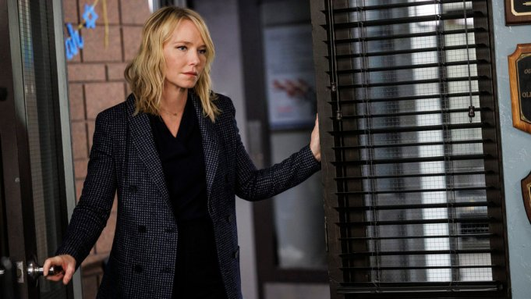

Peter Kramer/NBC

**SPOILER ALERT:** *This story includes discussion of major plot points from the Dec. 8 “*[*Law & Order: SVU*](http://variety.com/t/law-and-order-svu)*” episode on NBC.*

Detective Amanda Rollins wasn’t an easy character to say goodbye to for [Kelli Giddish](https://variety.com/t/kelli-giddish/). The actor made [her final appearance](https://variety.com/2022/tv/news/kelli-giddish-leaves-law-and-order-svu-rollins-quits-1235381341/) on “Law & Order: SVU” on Thursday night, with her character marrying Carisi (Peter Scanavino) and choosing to leave the squad for a teaching gig.

Giddish, who joined the series in 2011, [announced her exit](https://variety.com/2022/tv/news/kelli-giddish-exits-law-and-order-svu-amanda-rollins-1235349013/) ahead of the Season 24 premiere and *Variety* confirmed at the time that the [choice to leave the Dick Wolf series was not hers](https://variety.com/2022/tv/news/why-is-kelli-giddish-leaving-law-and-order-svu-1235350955/).

## **Related Stories**



[VIP+](https://variety.com/vip/the-blueprint-for-warner-bros-discoverys-fast-business-1235453033/)

### [**The Blueprint for Warner Bros. Discovery’s FAST Business**](https://variety.com/vip/the-blueprint-for-warner-bros-discoverys-fast-business-1235453033/)



### [**Michelle Yeoh Nearly Quit ‘Everything Everywhere All At Once’ Over Character’s Name: If It Doesn’t Change, ‘I’m Not Coming In’**](https://variety.com/2022/film/news/michelle-yeoh-nearly-quit-everything-everywhere-all-at-once-character-name-1235452960/)

Following her final episode, she opened up about the tough exit, filming her final scenes and the possibility of seeing Rollins again in the future. Read the full Q&A below.

**What an amazing final episode. How do you feel today?**

There is a finality to it that wasn’t there yesterday, so it feels different than it did before I saw it, which I wasn’t expecting! I kind of said my goodbyes on set. I had that closure, I thought. But last night, just so see how many people were watching and all the kind words I got about Rollins and the show, it was really something special.

**Rollins has meant so much to so many people. What does she mean to you?**

I started playing her in my late 20s, so I’ve played her in three decades of my life, which is nuts. It’s insane. This is a show unlike any other. Shows don’t *last* 12 years, much less getting to play a character. With playing someone as multi-faceted as Rollins, I got to play all kinds of different things — down and out, on top, joyful, doubtful, scared, triumphant. I got to do the gambit.

**What have you learned from Rollins?**

So much. It’s possible to grow, it’s possible to be hurt and to love again.

**Let’s go back a bit. Everyone was pretty shocked to hear that you were leaving. Can you share what happened, since you’ve never told your side of things?**

My side of things is just that it’s time in the Rollins storyline. I felt like where it was heading, and where it headed last night, just seemed the right place to leave it right now. I am so excited about things going on in my personal life and kind of the mirroring of what’s going on in my personal life and in Rollins’, there’s a lot of joy to be experienced.

**When did you find out that you’d be leaving?**

Before the season started, this year. We worked on this storyline together, and I think the last episode culminated the beautiful Rollins and Benson relationship, and we got to see Carisi and Rollins get married, which was such a treat.

**The wedding was so exciting. How did you react when you found out that was happening?**

I was so happy, because I was like, “Thank God” — because the fans are going to freak out if they don’t get it! Let’s give it to them.

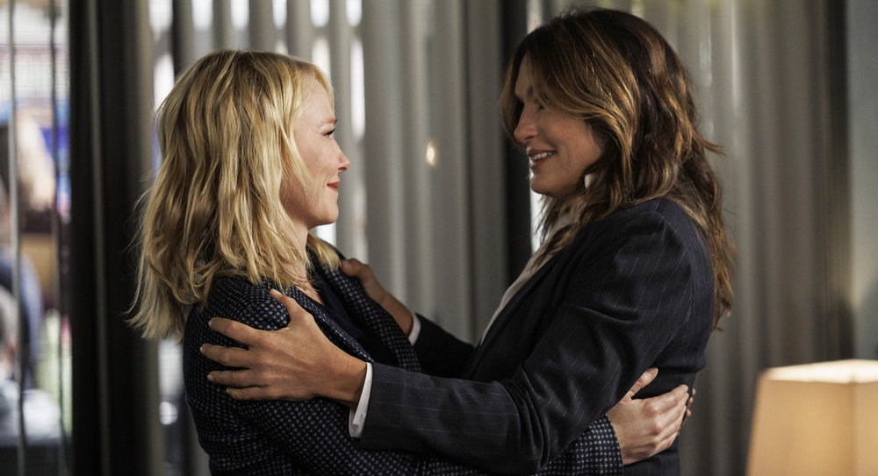

Kelli Giddish as Detective Amanda Rollins and Mariska Hargitay as Captain Olivia BensonPeter Kramer/NBC

**You and Mariska Hargitay are so close and had some really beautiful scenes in the finale. What was it like filming those?**

It was very emotional. We had a ton of fun because acting with my girl is just fun. There’s so much trust there, and you can play because we know each other so well. Nothing is set in stone, and if you want to try something, the writers are right there because they trust Mariska and I to kind of fine-tune the words of the script. It’s so much fun, there’s so much laughter and there were so many tears. It was a really beautiful experience.

**Rollins will appear in an upcoming** [**episode of “Organized Crime.”**](https://variety.com/2022/tv/news/when-is-kelli-giddish-last-law-and-order-svu-episode-date-1235399228/) **what can you tell us about that part?**

I don’t know what I can tell you about that!

**She took a job in New York, so she won’t be far away. And she’s now married to Carisi, who is still part of the show. So is the door open to return?**

The door is un-shut. The world that Dick Wolf has created with all these shows now — I mean, the crossovers that happen, the people that come back. [Chris Meloni was gone for 12 years](https://variety.com/2020/tv/news/elliot-stabler-series-nbc-christopher-meloni-dick-wolf-1203550428/) and then his character came back. S. Epatha [Merkerson] is on “[Chicago Med](http://variety.com/t/chicago-med).” These these characters are so beloved and so well-defined, because you get to see them day in and day out. We’re in people’s living rooms. So the audience loves these characters, they know us. Dick Wolf has got such a fertile universe that’s going on, that people can pop up in different places. That’s really a cool thing that he’s created.

**Lastly, there was a big story in the** [***L.A. Times* yesterday about showrunner David Graziano**](https://www.latimes.com/entertainment-arts/business/story/2022-12-08/law-order-svu-showrunner-faces-complaints)**. What was your reaction to reading that, and what has your experience been with him?**

It was alarming to read. My experience has always been positive on the set for all 12 years that I was there.

*This interview has been edited and condensed.*